**Verification of KVL Using Breadboard:**

**Objective:**

* To know about KVL.
* Using KVL and find the voltage in different resistors.
* Practical work on Breadboard.

**Kirchhoff’s Voltage Law:**

Kirchhoff’s Voltage Law states that in any closed loop network, the total voltage around the loop is equal to the sum of all the voltage drops within the same loop which is also equal to zero. In other words, the algebraic sum of all voltages within the loop must be equal to zero.

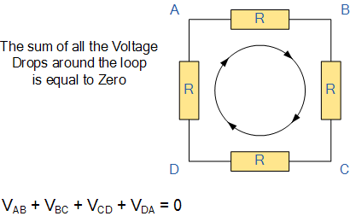

**Mathematically:**



The overall equation for the above circuit is:

E1-E2 = i1R1 + i2R2 – i3R3 – i4R4

**Apparatus:**

Apparatus used in this verification experiment is given as follow:

1. Breadboard
2. Voltage source
3. Resistors
4. Connecting wires.
5. Digital multi-meter

**Procedure:**

* First of all take a break board and resistors.
* Take three resistors of the same resistance and three resistors of different resistance.
* Now place the resistors on the breadboard in series.
* Apply the voltage source.
* Now check the voltage drop across each resistor.
* You will see that sum of the voltage drop will be equal to the applied voltage or we can say that sum of voltage drop and the applied voltage will be equal to ZERO.

**OBSERVATIONS AND CALCULATIONS**

|  |  |  |  |  |  |  |  |
| --- | --- | --- | --- | --- | --- | --- | --- |
| S.NO | Power  Supply | Measured  Voltage | V1 | V2 | V3 | Vtotal=V1+V2+V3 | Error |
| Same Resistors | | |
| 1 | 5V | 5.2V | 1.7V | 1.7V | 1.7V | 5.1V | 1.92% |
| 2 | 15V | 15.13V | 5.03V | 5.03V | 5.03V | 15.09V | O.26% |
|  |  |  | Different Resistors | | |  |  |
| 3 | 5V | 5.2V | O.4V | 1.7V | 3.05V | 5.15V | 0.96% |
| 4 | 15V | 15.13V | 1.25V | 4.67V | 9.19V | 15.11V | 0.13% |

**ANALYSIS:**

From the above experimental result we have seen that there is a little difference between source voltage which is measured with the help of DMM. This is because we can’t prove every law 100% correctly practically. All the laws are verified theoretically or mathematically but not practically. But at the same time we see that this difference is very less and may be negligible which gives the proofs of KVL. Only in the 1st case the error is 1.92% which is greater as compared to the other cases.